

A

PROJECT REPORTON

# “DYMANIC PORTFOLIO FOR DIKSHA FITNESS STUDIO”

## SUBMITTED TO

SHIVAJI UNIVERSITY, KOLHAPUR.

**FOR THE AWARD OF**

“ M.Sc. COMPUTER SCIENCE IN CYBER SECURITY ”

**(SEM II)**

## By

**Mr. Prathamesh Pradeep Khade (Roll : 10)**

UNDER THE GUIDANCE OF

### Prof. Ankita Teli

(SCHOOL OF COMPUTER SCIENCE)

THROUGH

CSIBER COLLEGE, KOLHAPUR. (Autonomous)

#### 2023-2024

**CHATRAPATI SHAHU INSTITUTE OF**

**BUSSINESS EDUCATION & RESEARCH,**

**KOLHAPUR.**

CERTIFICATE

This is to certify that, *Mr. Prathamesh Pradeep Khade* has satisfactorily carried out project work entitled -

“Dynamic Portfolio for *Diksha’s Fitness Studio*” for

**Chatrapati Shahu institute of business & research, Kolhapur** as partial fulfilment of the course MSC.CS in Cyber Security for academic year I sem-II.

**Place : Kolhapur**

**Date:** 23/05/2024

**Head of**

**School of Computer Studies Examiner**



**CHATRAPATI SHAHU INSTITUTE OF**

**BUSSINESS EDUCATION & RESEARCH,**

**Kolhapur**

Guide’s Certificate

**This is to certify that Mr. Prathamesh Pradeep khade under the guidance of**

Mrs Ankita Teli **satisfactory completed the project work on “Dynamic Portfolio for Diksha’s Fitness Studio” for the field work project of M.Sc. Computer Science in Cyber Security (Sem II) at CSIBER, KOLHAPUR during the academic year 2023-2024. To best knowledge & belief the matter presented by them are original & not copied for any source. Also, this report has not been submitted earlier for the award of any Degree or Diploma of Shivaji University or any other University.**

**Date:** 23/05/2024

**Place: Kolhapur**

**Prof. Ankita Teli**

**(Project Guide)**

DECLARATION

Respected Sir/Madam,

I undersigned hereby declare that this project entitled **“Diksha Fitness Studio”** is conducted under the guidance of Prof. Ankita Teli this is my original work. The empirical finding in the report is based on the work conducted by me personally & is not a reproduction of any source.

If my work is found to be copied, then I will be liable to be punished under the rule.

Date: 23/05/2024

Place: KOLHAPUR

**Prathamesh Pradeep Khade**

**Roll NO:** 10

## ACKNOWLEGEMENT

This report has been made through direct & indirect cooperation of various person for whom we wish to express our appreciation & gratitude.

We are very thankful to **Prof. Ankita Teli** for guiding throughout our project & exceeding useful cooperation during the period with discussion & guidance to success our project works.

Words are insufficient to express our appreciation for the valuable advice & continuous motivation provided by MSc. Computer Science in Cyber Security (Sem-II)Department of Vivekanand College. I take this opportunity to express our deep gratitude to **Dr. S.D. Bohite (H.O.D of School of Computer Studies)**

**Prathamesh Pradeep Khade**

(MSc CS Cyber security II)

**INDEX**

|  |  |  |
| --- | --- | --- |
| **SR NO.** | **CONTENTS** | **Page no.** |
| **1** | **INTRODUCTION TO PROJECT**   * INTRODUCTION * EXISTING SYSTEM’s Working * NEED & SCOPE OF COMPUTER SYSTEM. * ORGANIZATION PROFILE | **8 - 10** |
| **2** | **PROPOSED SYSTEM**   * REQUIREMENT ENGINEERING * REQUIREMENT GATHERING * OBJECTIVES * SRS | **10 - 13** |
| **3** | **SYSTEM ANALYSIS & SYSTEM DIAGRAMS**   * DATA FLOW DIAGRAM * ENTITY RELATIONSHIP DIAGRAM * UML | **14 - 16** |
| **4** | **SYSTEM DESIGN** | **17 - 22** |
| **5** | **IMPLEMENTATION**  **-** SYSTEM REQUIREMENTS   * HARDWARE * SOFTWARE * USER GUIDELINE | **23** |
| **6** | **Code Design** | **24 - 29** |
| 7 | **CONCLUSION & SUGGESTION**   * CONCLUSION * LIMITATIONS   SUGGESTION | **30 - 31** |
| 8 | **BIBLIOGRAPHY** | **32** |

**1] INTRODUCTION TO PROJECT:**

**1.1) Introduction:**

The Diksha Fitness Studio project is a web development endeavour aimed at creating a visually appealing and user-friendly platform for a fitness studio. The website serves as an online portfolio and landing page, providing potential clients with essential information about the studio, its classes, and the owner's expertise. Additionally, it offers an intuitive admin panel for the studio owner to manage their personal details, classes, social media links, and client data.

This project leverages the Django framework, along with PostgreSQL for database management, HTML, CSS, JavaScript, and Bootstrap for front-end development, and Vercel for deployment. The website's modern design and responsive layout ensure an optimal user experience across various devices and screen sizes.

Key features of the Diksha Fitness Studio website include:

1. Home, About, Contact, and Classes pages for visitors to explore.
2. A secure admin panel for the studio owner to update personal details, class information, and manage social media links.
3. An integrated gallery for the studio owner to upload and showcase photos.
4. Client data management within the admin panel to keep track of current clients.

The Diksha Fitness Studio project demonstrates the successful combination of web development technologies to create an engaging and functional platform that caters to the needs of both the fitness studio owner and potential clients.

**1.2) Existing System Working:**

Prior to the implementation of the Diksha Fitness Studio website, the studio's operations and client management were conducted through manual, paper-based methods. The studio lacked an online presence, which limited its visibility and reach to potential clients. The owner relied on traditional advertising methods and word-of-mouth referrals to promote the business.

Client data, such as contact information and class registrations, was recorded and managed in a physical diary. This approach posed challenges in efficiently tracking client details, organizing class schedules, and maintaining up-to-date information. Furthermore, the manual process was time-consuming and prone to errors, hindering the overall productivity and growth of the fitness studio.

With the introduction of the Diksha Fitness Studio website, the owner can now establish an online presence, streamline client data management, and effectively promote classes and events. The digital platform not only enhances the studio's visibility but also enables the owner to manage and update information efficiently, ultimately contributing to the business's success.

**1.3) Need and Scope of Computer System for Portfolio Website:**

The primary need for the Diksha Fitness Studio project arises from the limitations of the existing manual system, which lacks an online presence and an efficient method for managing client data. To address these issues, the project aims to create a modern and dynamic website with a secure admin panel to manage the studio's operations effectively.

**Scope:**

1. **Design and develop a visually appealing and responsive website:** The website should showcase the fitness studio's services, classes, and owner's expertise, enhancing its online presence and attracting potential clients.
2. **Implement a user-friendly admin panel:** The admin panel should allow the studio owner to manage personal details, class information, social media links, and client data with ease.
3. **Integrate an image gallery:** The website should include a gallery section for the studio owner to upload and display photos, providing visitors with an engaging visual experience.
4. **Develop a secure and efficient client data management system:** The admin panel should enable the studio owner to store, organize, and track client data securely, eliminating the need for manual record-keeping.
5. **Deploy the website on a reliable hosting platform:** Vercel will be used to deploy the website, ensuring high performance, scalability, and accessibility for users.

By fulfilling these objectives, the Diksha Fitness Studio project will streamline the studio's operations, improve client management, and ultimately contribute to the growth and success of the business.

**2] PROPOSED SYSTEM:**

**2.1) Requirement Engineering:**

Functional Requirements:

1. Home Page: Display general information about the fitness studio, including its mission, vision, and contact details.
2. About Page: Provide details about the studio owner's qualifications, experience, and expertise.
3. Classes Page: Show a list of available fitness classes, descriptions, schedules, and pricing.
4. Contact Page: Include a contact form for users to send inquiries or feedback to the studio owner.
5. Gallery: Display a collection of photos showcasing the studio, classes, and events.
6. Admin Panel: Allow the studio owner to update personal information, manage class details, add social media links, and upload images to the gallery.
7. Client Data Management: Enable the studio owner to add, update, and delete client information within the admin panel.
8. Search Functionality: Implement search functionality for users to find specific classes or information on the website.

Non-Functional Requirements:

1. Performance: The website should load quickly and perform efficiently on various devices and browsers.
2. Security: Implement secure user authentication and protect sensitive data, such as client information, using industry-standard encryption and security measures.
3. Usability: The website should provide a user-friendly and intuitive interface for visitors and the studio owner.
4. Scalability: The website should be designed to accommodate future growth in traffic and content.
5. Maintainability: Adhere to best practices in code organization, documentation, and design patterns to ensure maintainability and ease of future updates or modifications.
6. Responsiveness: The website should be fully responsive and compatible with different screen sizes and devices, providing an optimal user experience.
7. Accessibility: Ensure that the website is accessible to users with disabilities and meets WCAG (Web Content Accessibility Guidelines) standards.

**2.2) REQUIREMENT GATHERING:**

**Requirements gathered:** For creating a Dynamic Portfolio Website the basic information of the project requirements will be taken from the owner of the Studio.

**Preliminary investigation using fact finding technique:**

For this we visited the studio and interviewed the owner of the studio and we gathered following information like

1. How the Studio engages the new customers?
2. What methodologies they have implemented for being stable it the competitive market?
3. How they maintain their client records?

**2.3) OBJECTIVES:**

1. **Establish a strong online presence:** Develop a visually appealing and informative website to showcase the fitness studio's services, classes, and owner's expertise, improving visibility and attracting potential clients.
2. **Enhance client management:** Implement a secure and efficient system for storing and managing client data within the admin panel, enabling the studio owner to easily track and organize client information.
3. **Streamline website administration:** Provide a user-friendly admin panel for the studio owner to manage personal details, class information, social media links, and upload images to the gallery without technical assistance.
4. **Improve user experience:** Create a responsive and intuitive website that offers easy navigation, search functionality, and an enjoyable browsing experience for users on various devices and browsers.
5. **Ensure security and reliability:** Implement industry-standard security measures and best practices for data protection, backup, and recovery, while ensuring optimal website performance and uptime through a reliable hosting platform like Vercel.

**2.4)** **Software Requirements Specification (SRS) of Diksha Fitness Studio Project:**

**1. Introduction:**

The Diksha Fitness Studio project aims to create a visually appealing, user-friendly website and admin panel to manage a fitness studio's online presence and client data efficiently.

**2. Functional Requirements:**

* User registration and login
* Informative website pages: Home, About, Classes, and Contact
* Gallery section for activities at the studio
* Admin panel for managing personal details, classes, social media links, and client data
* Search functionality for users

**3. Non-Functional Requirements:**

* Performance and efficiency
* Security and data protection
* Usability and user experience
* Scalability and maintainability
* Responsiveness and compatibility
* Accessibility and SEO
* Data backup and recovery

**4. Conclusion:**

The Diksha Fitness Studio project's SRS outlines the functional and non-functional requirements for creating an effective online platform to promote the fitness studio, manage client data, and ensure a secure and user-friendly experience. By meeting these requirements, the project will contribute to the growth and success of the business.

**3] SYSTEM ANALYSIS & SYSTEM DIAGRAMS:**

DATA FLOW DIAGRAM (DFD):

LEVEL-0

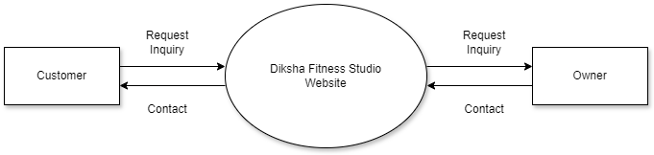

LEVEL-1

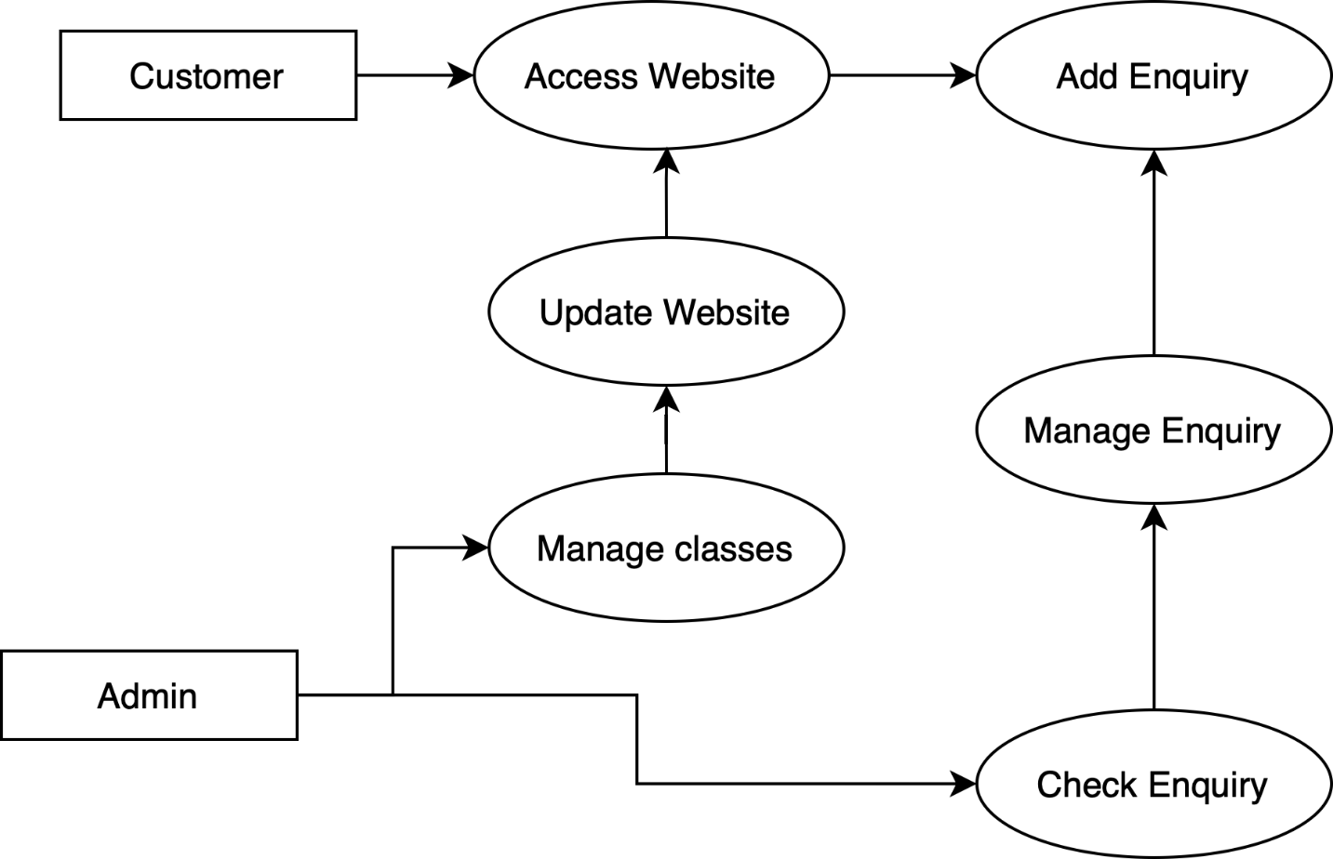

LEVEL-2 :

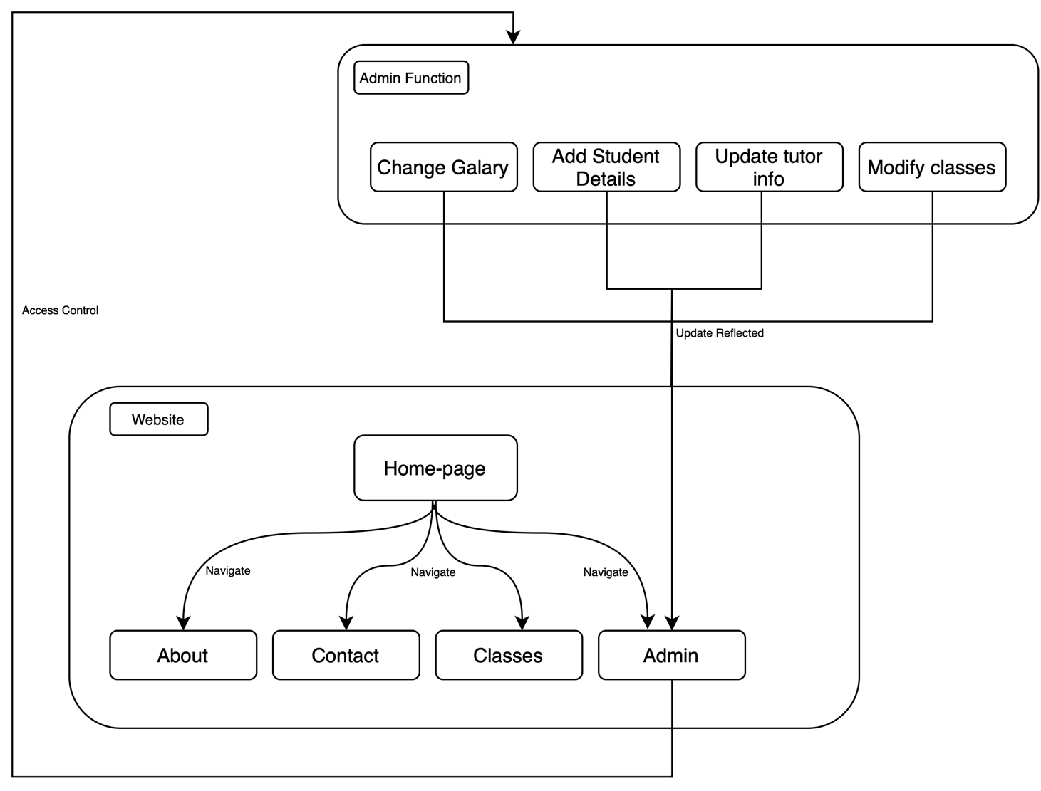

**Entity Relationship Diagram**

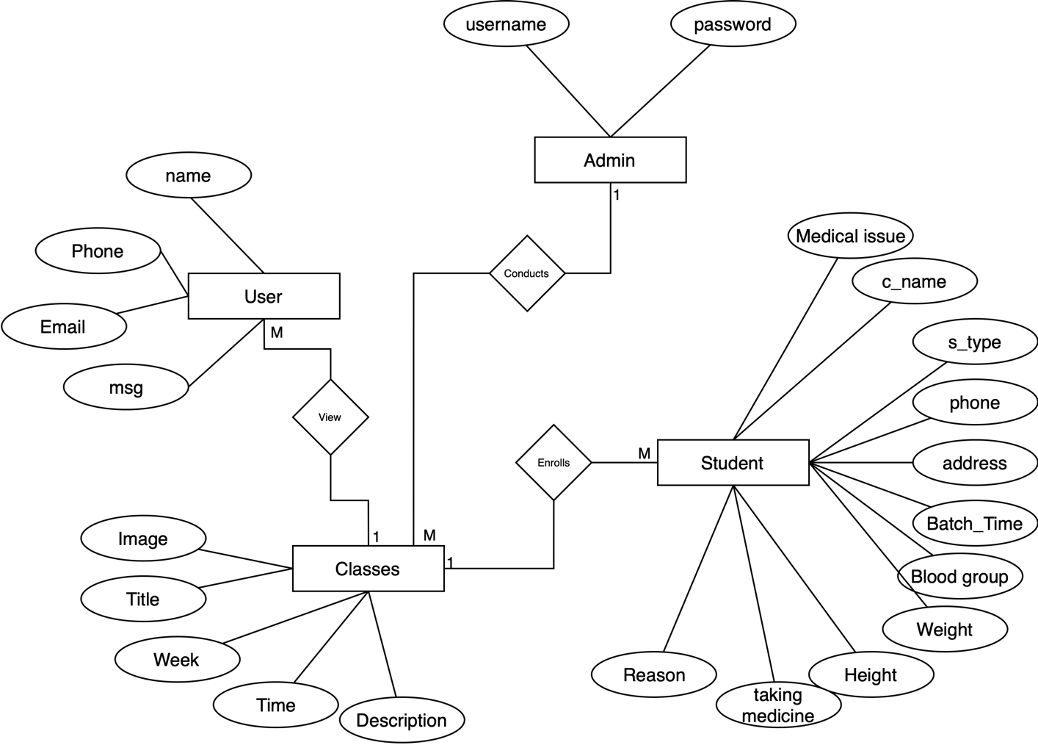

**4] System Design**

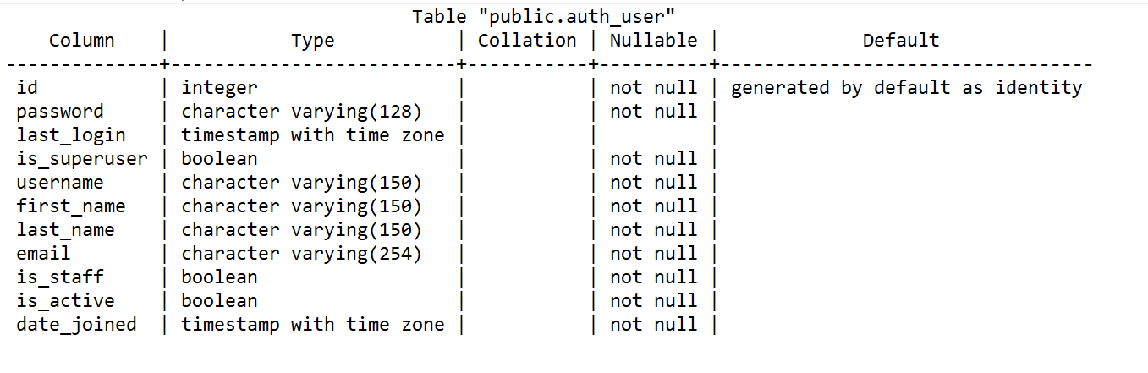**4.1) Database Designs:**

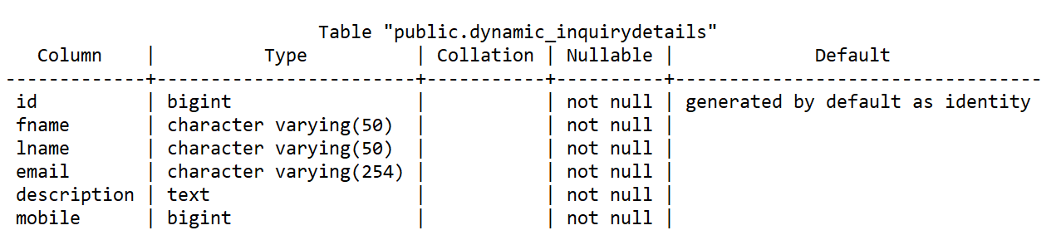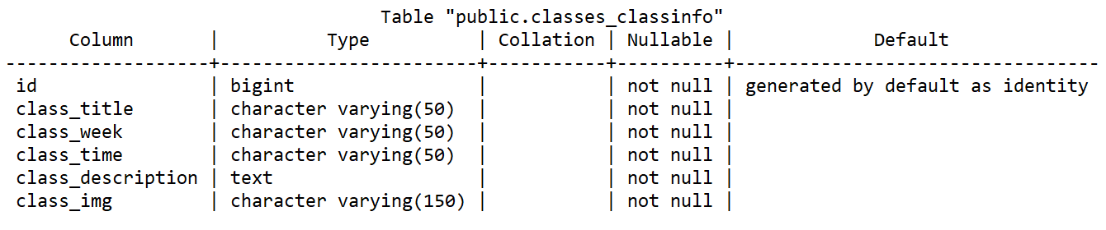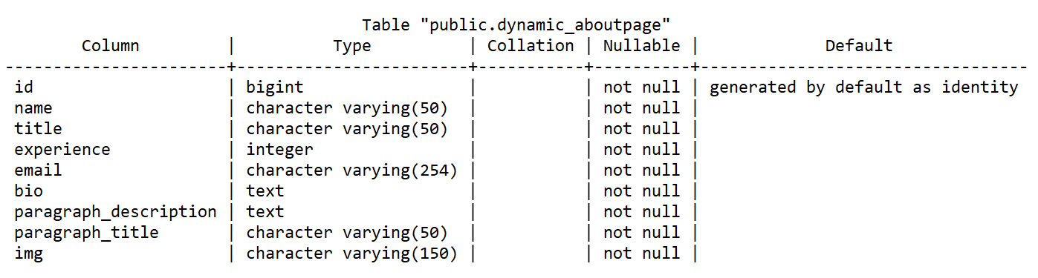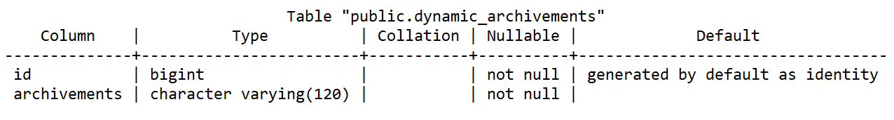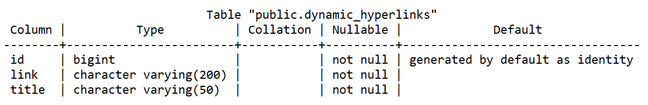

* **Home page**

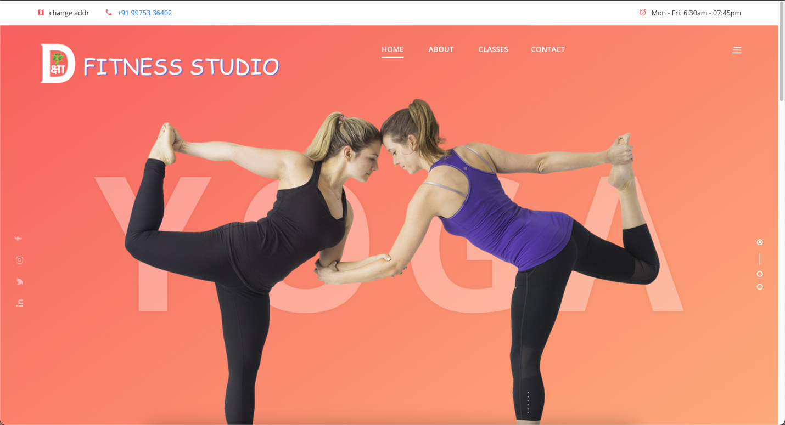

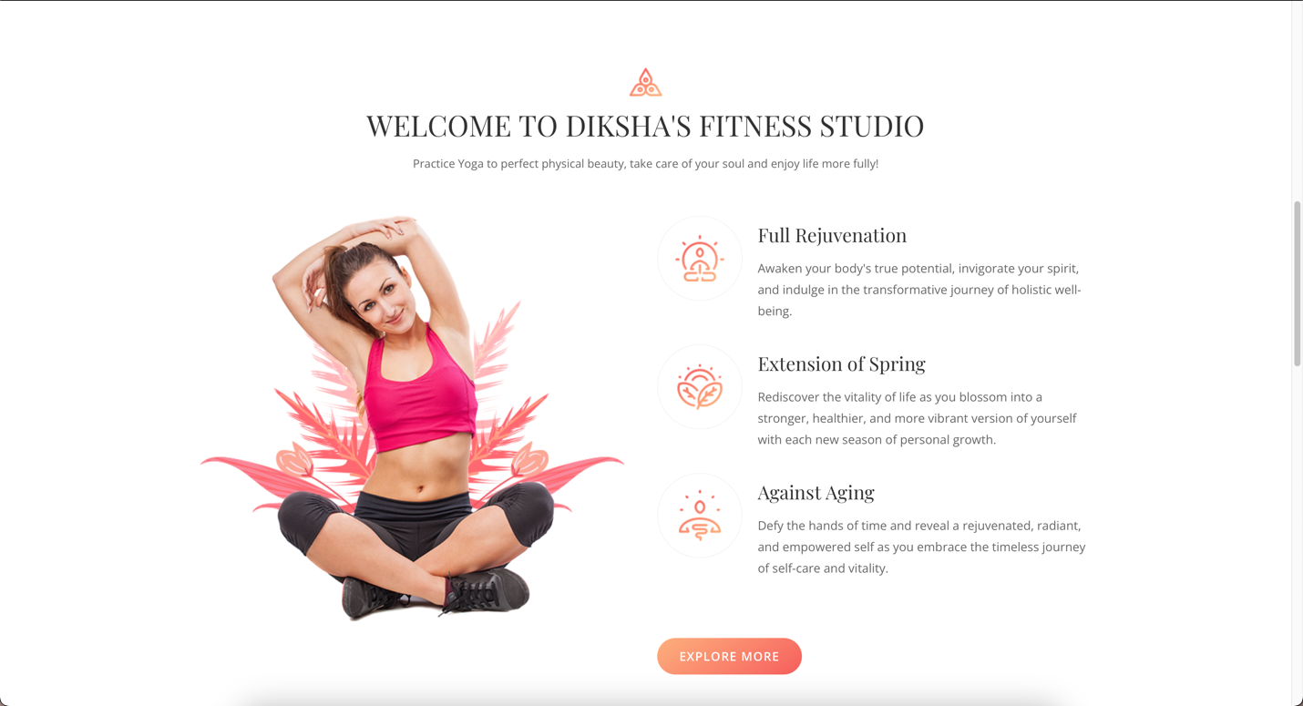

* **Classes**

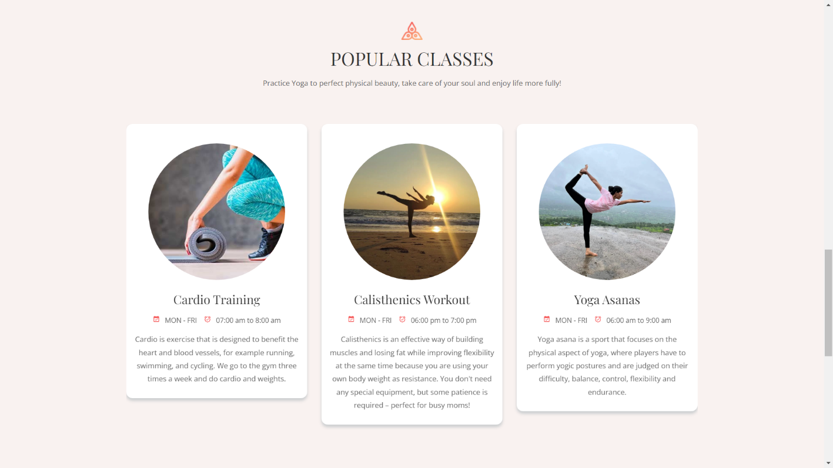

* **Contact**

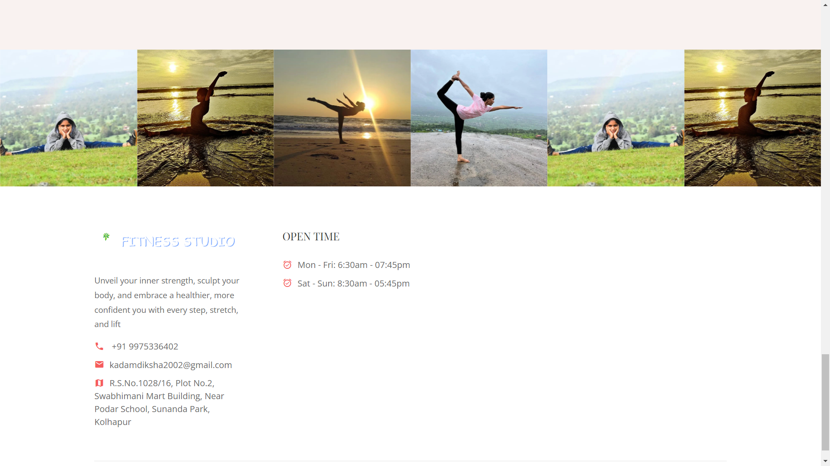

* **Admin Login**

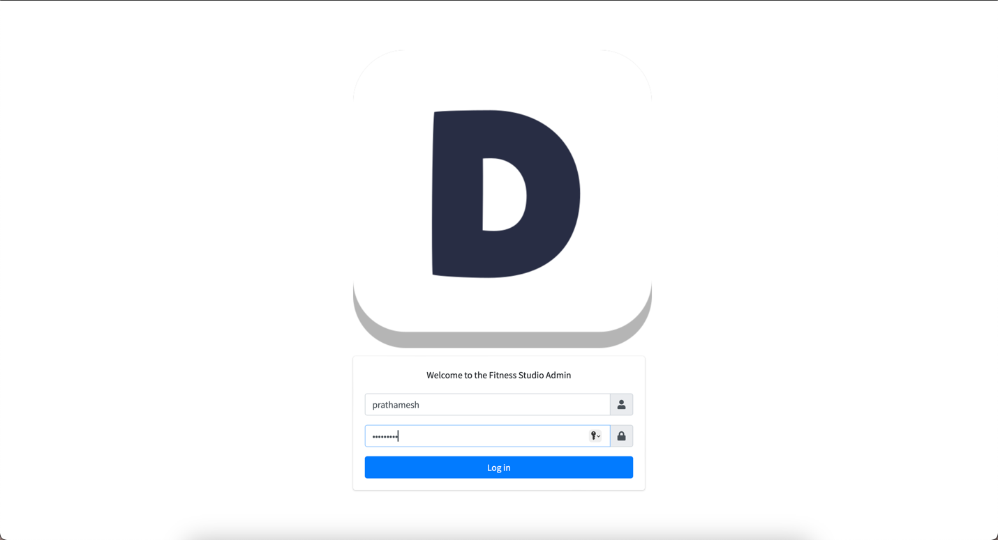

* **Admin Dashboard**

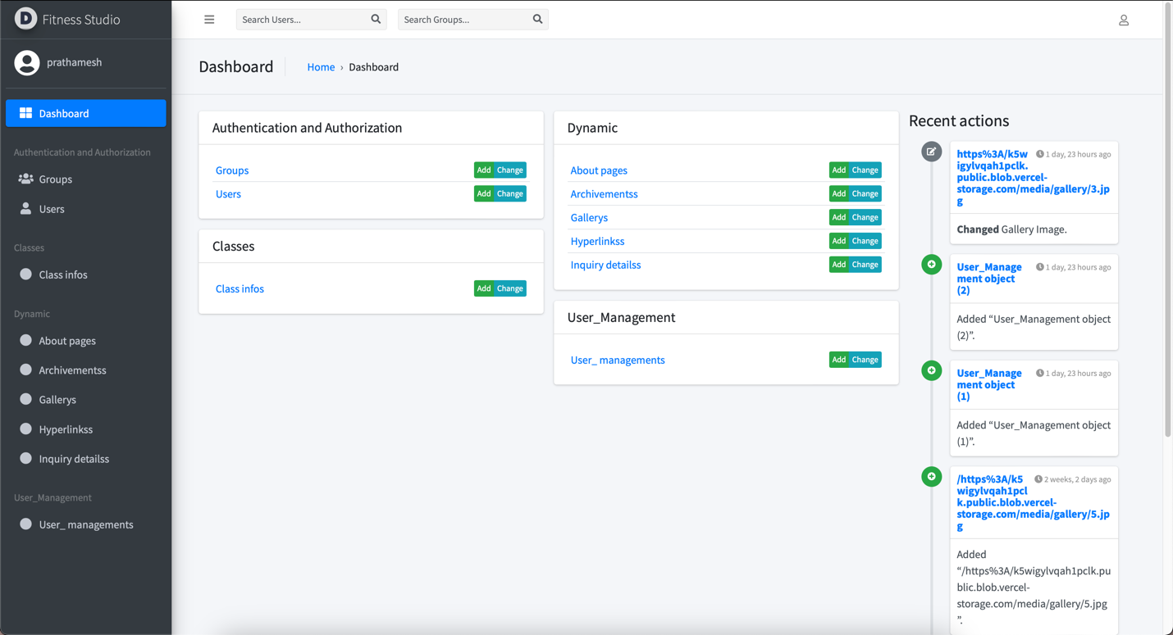

* **Admin Manage Classes**

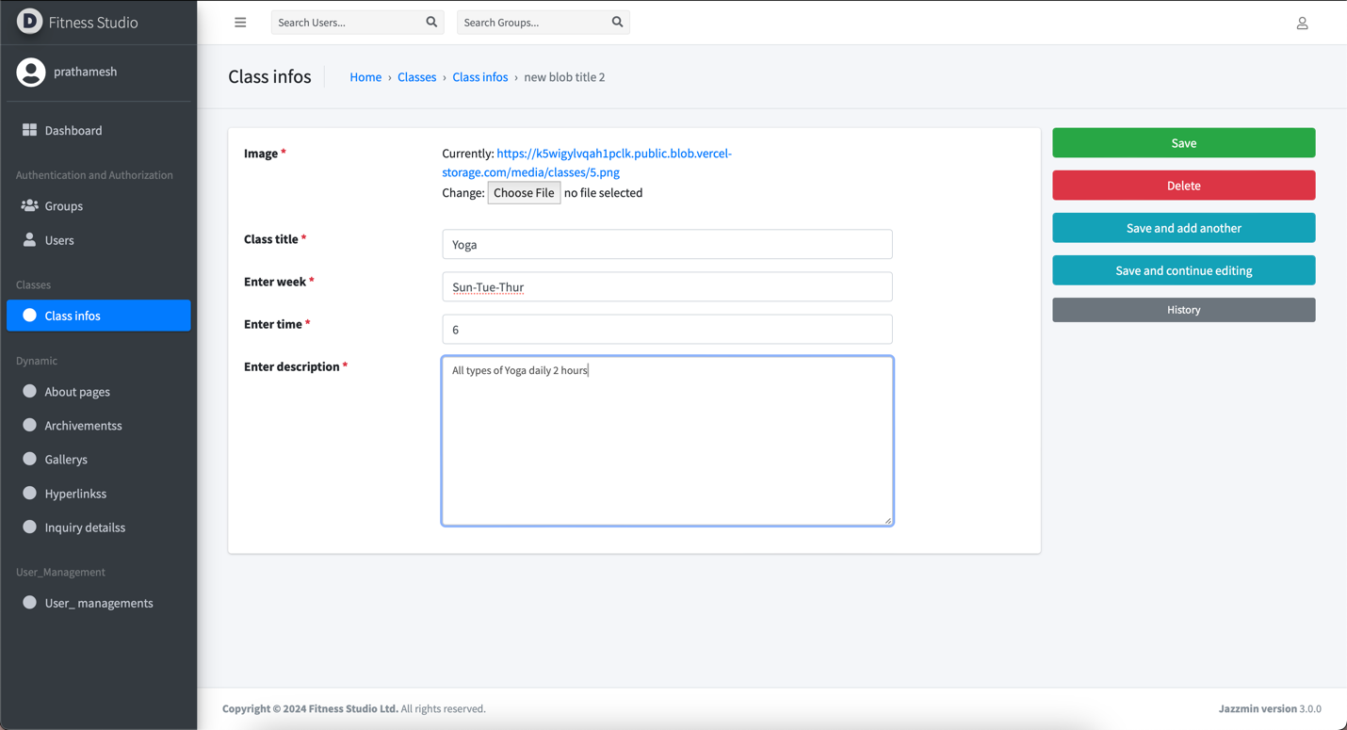

* **Admin User management**

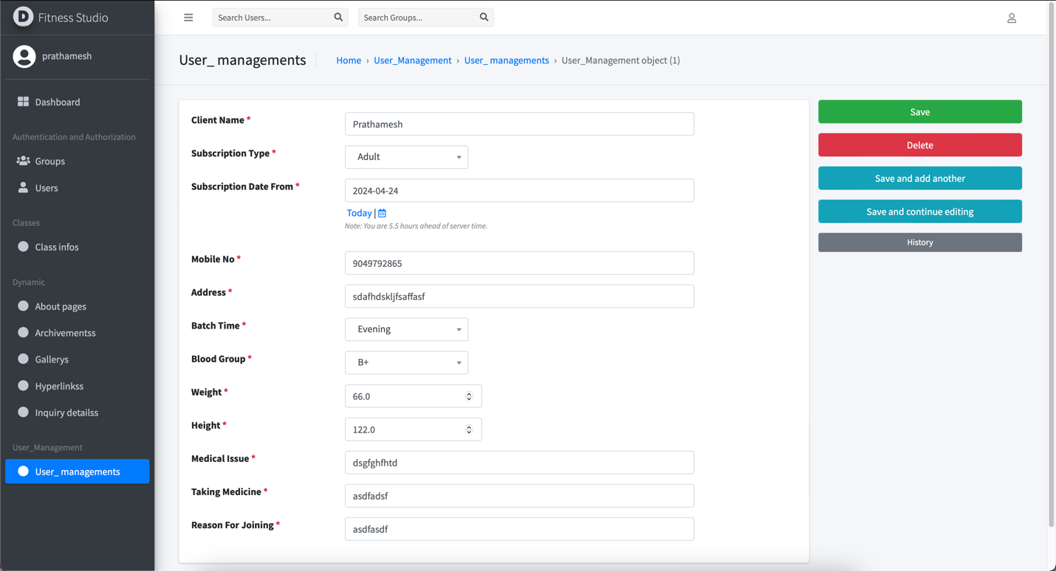

* **Admin Gallery Management**

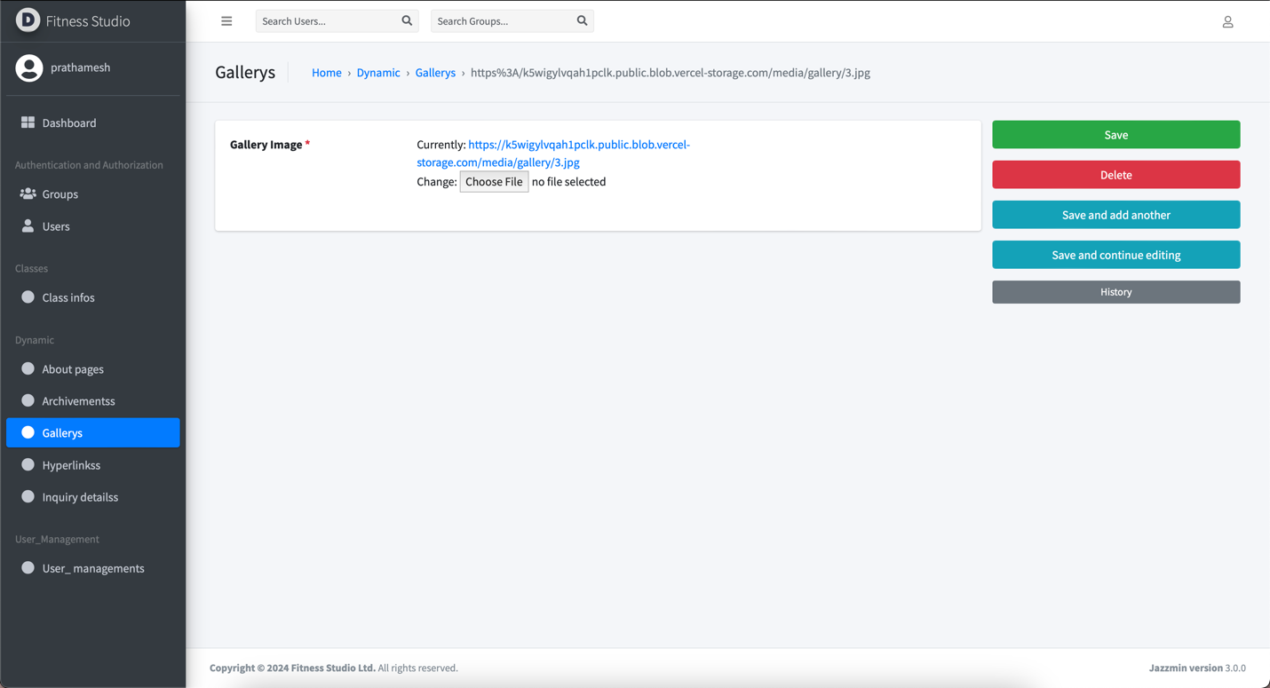

* **Admin Inquiry Management**

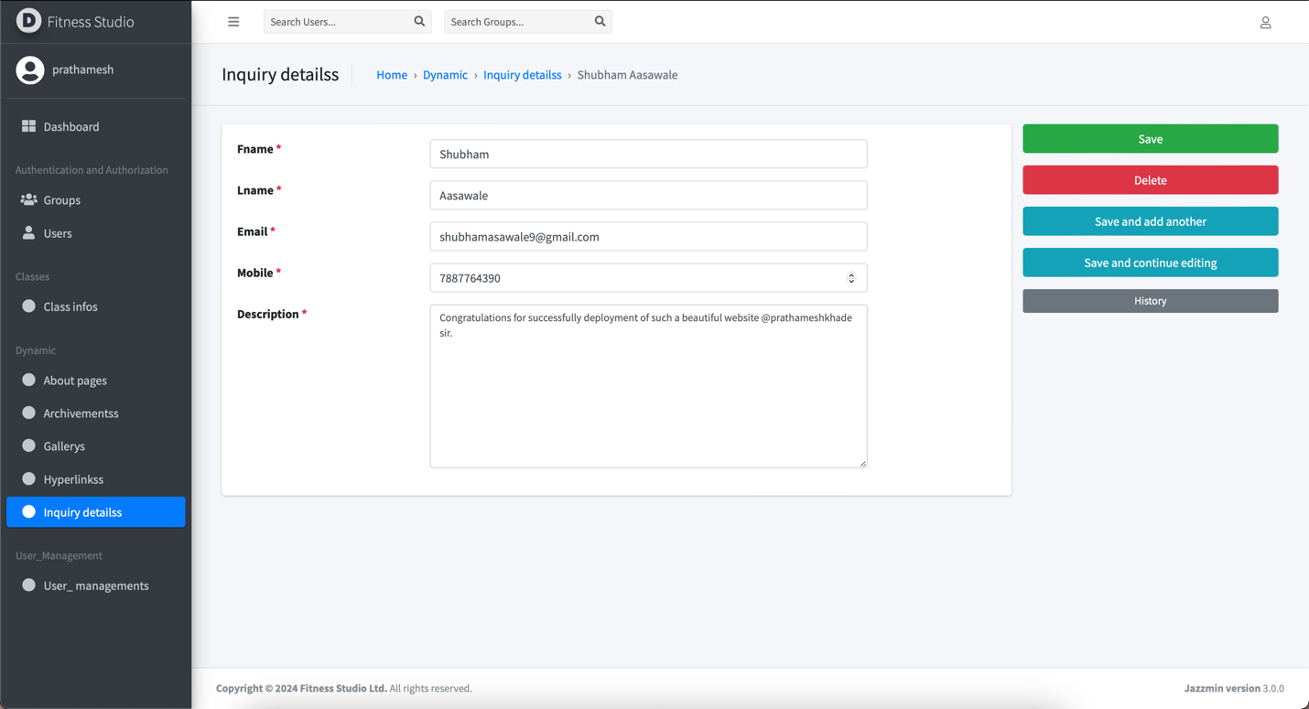

**5] System implementation**

* **SYSTEM REQUIREMENTS**

**Hardware**

* A computer or laptop with the following specifications:
  + Processor: Intel Core i3 or higher
  + RAM: 2 GB or higher
  + Storage: 10 GB or more
  + Display: 1280 x 800 resolution or higher
* A reliable internet connection for website deployment and updates

**Software**

* Operating System: Windows, macOS, or Linux
* Web Development Frameworks and Libraries: Django, HTML, CSS, JavaScript, and Bootstrap
* Database: PostgreSQL
* Deployment Platform: Vercel
* Web Browser: Google Chrome, Mozilla Firefox, or any modern browser for testing and browsing

1. **User Guidelines:**

* Users must have basic computer knowledge and internet browsing skills to access and navigate the website.
* The studio owner should be familiar with using web-based admin panels and managing digital content to effectively utilize the admin panel features.
* Users are encouraged to provide feedback or report any issues they encounter while using the website to help improve the platform's overall performance and user experience.

**6] Code Design :**

**Views.py**

from django.shortcuts import render

from django.http import JsonResponse

from src.dynamic.models import AboutPage, Archivements, Hyperlinks, InquiryDetails, Gallery

from src.classes.models import ClassInfo

# Fetch all the gallery images

gallery_images = Gallery.objects.all().values_list('gallery_image', flat=True).distinct()

# Create your views here

def homepage_view(request):

tdata = ClassInfo().getdata()

data = { 'data': tdata }

data['images'] = gallery_images

return render(request, "home.html", data)

def contact_view(request):

data = {}

data['images'] = gallery_images

return render(request, "contact.html", data)

def about_view(request):

table_data = AboutPage.objects.get(id=1)

data = {

'image': table_data.img,

'name': table_data.name,

'title': table_data.title,

'experience': table_data.experience,

'email': table_data.email,

'bio': table_data.bio,

'paragraph_title': table_data.paragraph_title,

'paragraph_description': table_data.paragraph_description

}

# adding archivements from table to website

data['archivements'] = [

x.archivements for x in Archivements.objects.all()

]

# adding hyperlinks in data

data['hyperlinks'] = Hyperlinks().getdata()

# adding images to data

data['images'] = gallery_images

return render(request, "about.html", data)

def classes_view(request):

tdata = ClassInfo().getdata()

data = { 'data': tdata }

data['images'] = gallery_images

return render(request, "classes.html", data)

def save(request):

saved = False

if request.method=="POST":

fname = request.POST.get('fname')

lname = request.POST.get('lname')

email = request.POST.get('email')

mob = request.POST.get('mob')

desc = request.POST.get('desc')

obj = InquiryDetails(fname=fname, lname=lname, email=email, mobile=mob, description=desc)

obj.save()

saved = True

return JsonResponse({'success': saved})

**Models.py**

from django.db import models

from vercel_storage import blob

# Create your models here.

class AboutPage(models.Model):

name = models.CharField(max_length=50)

img = models.ImageField(("image"), upload_to=None, default=None, max_length=150)

title = models.CharField(max_length=50)

experience = models.IntegerField()

email = models.EmailField(max_length=254)

bio = models.TextField(default="Tell about yourself here...")

paragraph_title = models.CharField(max_length=50, default="Enter title here...")

paragraph_description = models.TextField(default="Describe about your title mentioned above...")

def save(self, *args, **kwargs):

if self.img:

image_file = self.img.file.read()

vercel_blob_url = blob.put(pathname=f"media/about/{self.img.name}", body=image_file, options={"no_suffix": True})["url"]

self.img = vercel_blob_url

super().save(*args, **kwargs)

class Archivements(models.Model):

archivements = models.CharField(("awards and archivements"), max_length=120)

def __str__(self) -> str:

return self.archivements.capitalize()

class Hyperlinks(models.Model):

title = models.CharField(("Title for hyperlink"), max_length=50)

link = models.URLField(("Hyperlink"), max_length=200)

def __str__(self) -> str:

return f"{self.title}"

def getdata(self) -> dict:

try:

tabledData = Hyperlinks.objects.all()

data = {}

for x in tabledData:

data[x.title] = x.link

except Exception as e:

print(e)

else:

return data

class InquiryDetails(models.Model):

fname = models.CharField(("fname"), max_length=50)

lname = models.CharField(("lname"), max_length=50)

email = models.EmailField(("email"), max_length=254)

mobile = models.BigIntegerField(("mobile"))

description = models.TextField(("description"))

def __str__(self) -> str:

return f"{self.fname.capitalize()} {self.lname.capitalize()}"

class Gallery(models.Model):

gallery_image = models.ImageField(("Gallery Image"), upload_to=None, max_length=100, null=False)

def __str__(self) -> str:

return self.gallery_image.url.strip("/")

def save(self, *args, **kwargs):

if self.gallery_image:

image_file = self.gallery_image.file.read()

vercel_blob_url = blob.put(pathname=f"media/gallery/{self.gallery_image.name}", body=image_file, options={"no_suffix": True})["url"]

self.gallery_image = vercel_blob_url

super().save(*args, **kwargs)

def __del__(self) -> None:

blob.delete(pathname=f"media/gallery/{self.gallery_image}")

**7] Conclusion & Suggestion:**

**7.1) Conclusion:**

The Diksha Fitness Studio project successfully established a modern, dynamic, and user-friendly online platform to promote the fitness studio and efficiently manage its operations. By utilizing Django, PostgreSQL, and Bootstrap, the website offers an engaging and responsive design, ensuring an optimal user experience across various devices. The secure admin panel empowers the studio owner to manage their online presence and client data with ease, enhancing productivity and facilitating business growth.

Overall, the project demonstrates the effective integration of web development technologies and cybersecurity best practices, providing a robust and reliable solution for the fitness studio's digital needs. The deployment on Vercel ensures high performance, scalability, and accessibility for users worldwide, making the Diksha Fitness Studio website an invaluable asset for both the studio owner and potential clients alike.

**7.2) Limitations:**

1. **Limited Social Media Integration:** While the admin panel allows the studio owner to add social media links, it does not provide built-in social media sharing or integration with popular platforms such as Facebook, Instagram, or Twitter.
2. **Payment Processing:** The website does not include an online payment system for clients to book or pay for classes, limiting its potential as an e-commerce platform.
3. **Multilingual Support:** The website currently supports only one language, which may limit its accessibility for non-English speaking users or international clients.
4. **Advanced Analytics:** While the admin panel enables the studio owner to manage client data, it does not offer advanced analytics or reporting features to track website traffic, user behavior, or marketing campaign effectiveness.
5. **Limited Customization Options:** The website design and functionality are tailored to the fitness studio's specific requirements, but the admin panel does not provide extensive customization options for advanced users who may wish to make significant layout or feature changes without technical assistance.

Despite these limitations, the Diksha Fitness Studio website effectively fulfills its primary purpose of establishing a strong online presence and providing a user-friendly platform for managing the fitness studio's operations.

**7.3) Suggestion:**

1. **Integrate Social Media Features**: To improve the studio's online presence and marketing efforts, consider integrating social media sharing buttons and feeds directly into the website. This could help increase user engagement and attract potential clients from popular platforms like Facebook, Instagram, or Twitter.
2. **Add Payment Processing**: Incorporate a secure online payment system, allowing clients to book and pay for classes directly through the website. This could streamline the booking process and provide additional revenue opportunities for the fitness studio.
3. **Implement Multilingual Support**: To cater to a broader audience and improve accessibility for non-English speaking users, consider adding multilingual support to the website. This could help the studio expand its reach and attract international clients.
4. **Include Advanced Analytics**: Integrate analytics tools such as Google Analytics or Matomo to track website traffic, user behavior, and marketing campaign performance. This data could help the studio owner make informed decisions to optimize their online presence and improve user experience.
5. **Enhance Customization Options**: Provide advanced customization options within the admin panel, allowing users with technical knowledge to make more significant layout or feature changes without extensive coding. This could help the studio adapt to changing needs or industry trends more efficiently.

By implementing these suggestions, the Diksha’s Fitness Studio website could continue to evolve and better serve the needs of both the studio owner and potential clients, further contributing to the success and growth of the business.

**8] Bibliography:**

* **Websites:**
* **Vercel Documentation:**
  + Official Website: <https://vercel.com/docs/>
* **StackOverFlow:**
  + Official Website: <https://stackoverflow.com/>
* **Django Documentation:**
  + Official Website: [https://docs.djangoproject.com/en/5.0/](https://docs.djangoproject.com/en/5.0/%20)
* **Github(for version control):**
  + Official Website: <https://github.com/>
* **Docker Containerization Docs:**
  + Official Website: <https://docs.docker.com/>
* **AI Technologies used:**
* Google’s GEMINI
* Pi.Ai
* DiagramGPT